chapter 11

Species Recognition in Flowers

Introduction
The conventional approach of the human person for plant classification is comparing the color and shape of the leaves, but by using Artificial Intelligence analysis can provide quicker and more detailed results by analyzing the morphology of the leaves and provides more details about the leaf properties. Species Recognition has been a very important part of agriculture and there are thousands of species in plants which can be identified by a single person and even if it does so It will take a huge lot of time to do it.
In this chapter we will discuss and built a project related to identify species in flower with an image. In this project we will be using Artificial Intelligence different branches like machine learning, deep learning and computer vision to build such an amazing project. So, let’s begin

Installation of Packages
In this species Recognition we have used so many libraries which need be installed before implementing this project. The command for installing these libraries are
- Warnings- pip install pytest-warnings/warnings
- NumPy- pip install Numpy
- hPandas- pip install pandas
- Matplotlib- pip install matplotlib
- Seaborn- pip install seaborn
- Tqdm- pip install tqdm
- Pillow/PIL- pip install pillow
- TensorFlow- pip install TensorFlow
- Keras- pip Install keras
For Python IDE: Enter these provided commands on the command prompt in windows For Anaconda: Enter these commands on Anaconda Prompt
If you are using any other Environment or IDE then you have to specify the path for python and you can do the installation.
This project was implemented in Google Research Collaboratory. And you can download the copy of the code form this link

Dataset
In this project we are using a dataset from Kaggle which has 5 categories of species in flowers namely daisy, dandelion, rose, sunflower and tulip which totally consist of 4242 images with 320×240 pixels. The images in the dataset is based on the data flicr, google images and Yandex images. These images can be used to recognize the plant related to these species.
You can download the same dataset from this link

Implementation:
Note: This project is purely implemented on google research Collaboratory which you access by this link and you are free to use any other IDE for project implementation.
Step 1: Importing all the Libraries
Note: The Symbol # represents the comment in the project which will make you understand about the code.
# Ignore the warnings import warnings
warnings.filterwarnings ('always') warnings.filterwarnings ('ignore')

# data visualisation and manipulation import numpy as np
import pandas as pd
import matplotlib.pyplot as plt from matplotlib import style import seaborn as sns

#configure
# sets matplotlib to inline and displays graphs below the corressponding cell.
% matplotlib inline style.use ('fivethirtyeight')
sns.set (style='whitegrid',color _ codes=True)

#model selection
from sklearn.model _ selection import train _ test _ split from sklearn.model _ selection import KFold
from sklearn.metrics import accuracy _ score,precision _ score,recall _ score,confusion _ matrix,roc _ curve,
roc_ auc_ score
from sklearn.model _ selection import GridSearchCV from sklearn.preprocessing import LabelEncoder

#preprocess.
from keras.preprocessing.image import ImageDataGenerator

#These are deep learning libraries which is present in keras if you have installed keras these all will get installed automatically.
from keras import backend as K from keras.models import Sequential from keras.layers import Dense
from keras.optimizers import Adam,SGD,Adagrad,Adadelta,RMSprop from keras.utils import to _ categorical

# we use these libraries specifically for CNN (convolutional Neural Network) Building which will be used to use to recognize the species of flower.
from keras.layers import Dropout, Flatten,Activation from keras.layers import Conv2D, MaxPooling2D,
BatchNormalization

import tensorflow as tf import random as rn

# here we are using OpenCV library to give input to the trained model and specifically for manipulating zipped images and getting NumPy arrays of pixel values of images.
import cv2
import numpy as np from tqdm import tqdm import os
from random import shuffle from zipfile import ZipFile from PIL import Image
Step 2: Mounting to drive for dataset
If you are using the google research Collaboratory then you can download the dataset from this link and upload it in your google drive “Colab Notebooks” folder then you can link it by using this code
from google.colab import drive drive.mount (‘/gdrive’)
Output:
Go to this URL in a browser: https://accounts.google.com/o/oauth2/auth?client_ id=94 y
Enter your authorization code:
··········

Mounted at /gdrive
This is the code for mounting your drive with google research Collaboratory which will ask you authentication which you can do it with your Gmail account by just following the simple steps. As you can see in the output how Collaboratory will ask you to verify it by clinking in the given link then it will get mounted by giving a authentication to it.
with open ('/gdrive/My Drive/foo.txt', 'w') as f: f.write ('Hello Google Drive!')
!cat '/gdrive/My Drive/foo.txt'
Output:
Hello Google Drive!
This is the code which will help you to check whether your drive has been mounted with the Collaboratory or not.
After doing this we will access our dataset which has been uploaded in the drive directly and unzip it to access the files which we require in this project.
Step 3: Getting Data ready for Model
Here we are forming an array of images X and Y which will store all the images in the form of training and validation images for the CNN model to train and get tested with real data.
X=[]
Z=[]
IMG _ SIZE=150 #assigning the image size constantly for the project FLOWER _ DAISY _ DIR='drive/Colab Notebooks/flower recog/flowers/ daisy'
FLOWER _ SUNFLOWER _ DIR='drive/Colab Notebooks/flower recog/ flowers/sunflower'
FLOWER _ TULIP _ DIR='drive/Colab Notebooks/flower recog/flowers/ tulip'
FLOWER _ DANDI _ DIR='drive/Colab Notebooks/flower recog/flowers/ dandelion'
FLOWER _ ROSE _ DIR='drive/Colab Notebooks/flower recog/flowers/ rose'
Creating a function to label the images in the data which will be further used for training purpose.
def assign _ label (img,flower _ type):
return flower _ type
here after labelling we will make a training data Separately from each categories of flower
def make _ train _ data (flower _ type,DIR): for img in tqdm (os.listdir (DIR)):
label=assign _ label (img,flower _ type)

path = os.path.join (DIR,img)
img = cv2.imread (path,cv2.IMREAD _ COLOR) img = cv2.resize (img, (IMG _ SIZE,IMG _ SIZE))

X.append (np.array (img)) Z.append (str (label))

# Training data for daisy
make _ train _ data ('Daisy',FLOWER _ DAISY _ DIR) print (len (X))

Output:
100%|██████████| 769/769 [00:07<00:00, 101.93it/s]769 #Training data for sunflower
make _ train _ data ('Sunflower',FLOWER _ SUNFLOWER _ DIR) print (len (X))
Output:
100%|██████████| 766/766 [00:07<00:00, 176.83it/s]1535

#training Data for Tulip
make _ train _ data ('Tulip',FLOWER _ TULIP _ DIR) print (len (X))
Output:
100%|██████████| 991/991 [00:08<00:00, 116.01it/s]2526
#trining data for dandelion
make _ train _ data ('Dandelion',FLOWER _ DANDI _ DIR) print (len (X))
Output:
100%|██████████| 1052/1052 [00:09<00:00, 114.67it/s]3578

#training data for Rose
make _ train _ data ('Rose',FLOWER _ ROSE _ DIR) print (len (X))
Output:
100%|██████████| 784/784 [00:06<00:00, 116.67it/s]4362
This is how training data for all the flowers is ready for the model to get trained.

Step 4: Visualizing the data
After Preparing the data for training we will visualize the data we have prepared using matplotlib and opencv.
fig,ax=plt.subplots (5,2) fig.set _ size _ inches (15,15) for i in range (5):
for j in range (2): l=rn.randint (0,len (Z)) ax[i,j].imshow (X[l])
ax[i,j].set _ title ('Flower: '+Z[l]) plt.tight _ layout ()
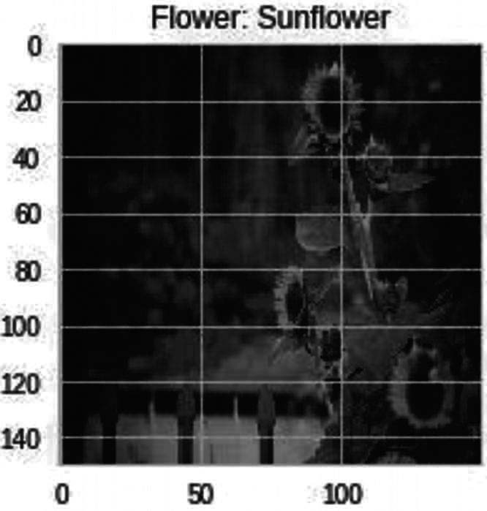
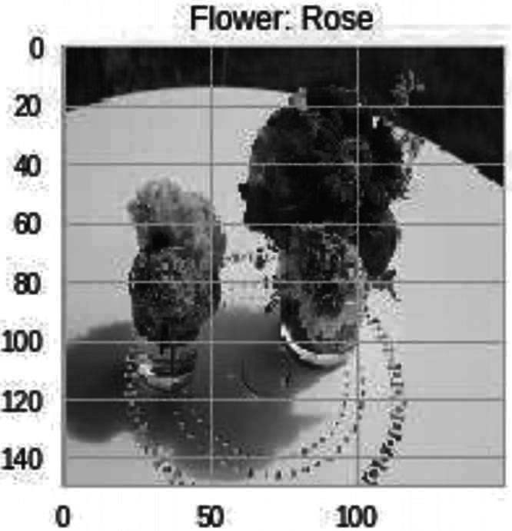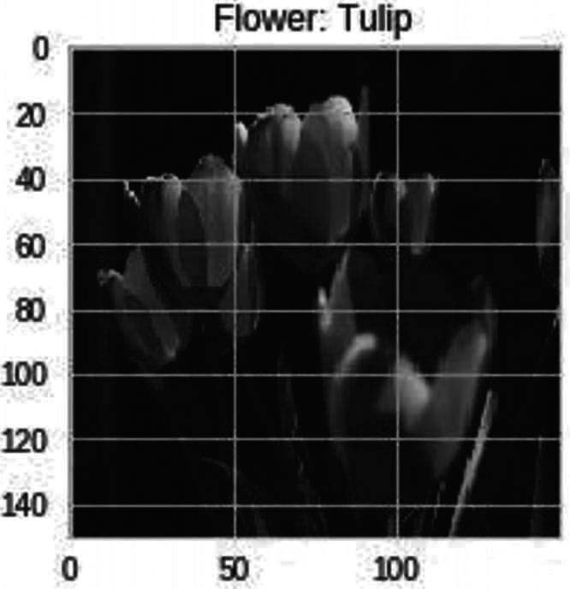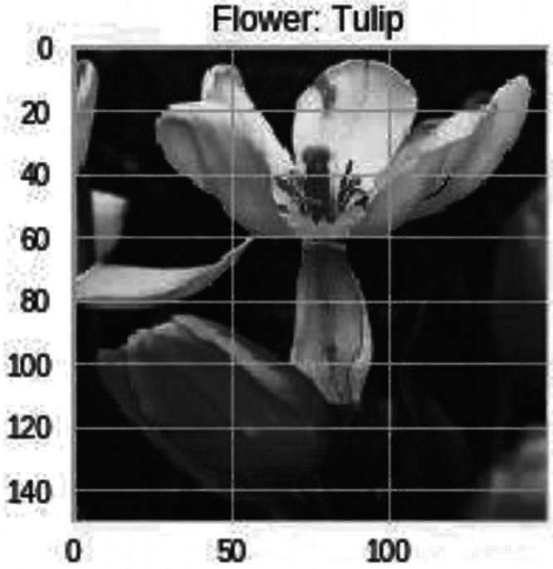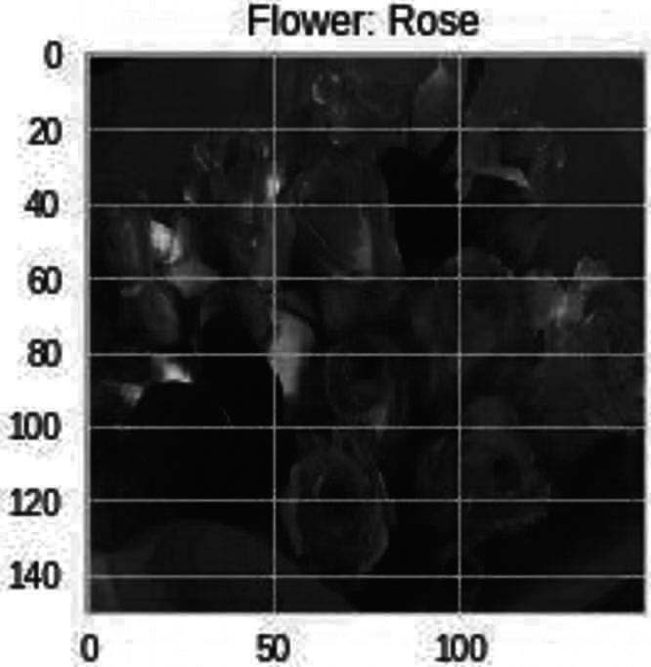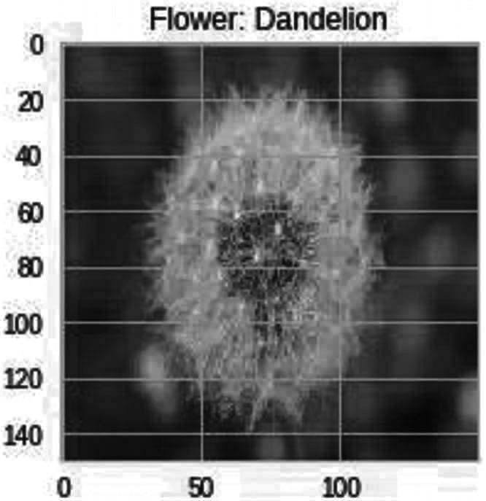Output: as I Fig. 11.1

Fig. 11.1 Data visualization from dataset

Step-5: Labelling the data and splitting it into training and validation data
#labelling le=LabelEncoder () Y=le.fit _ transform (Z) Y=to _ categorical (Y,5) X=np.array (X)
X=X/255

#After labelling we will do Splitting of data into Training and Validation Sets
x _ train,x _ test,y _ train,y _ test=train _ test _ split (X,Y,test _ size=0.25,random _ state=42)

#Setting the random seeds np.random.seed (42)
rn.seed (42)
tf.set _ random _ seed (42)
Step-6: Building The model
For building the model I have used Keras Sequential in which it is very easy to build any model for which we have a lot of images as input to extract features and classify them.
In the model creation, I have created four convolutional layer, In the first layer we have 32 filters, 5×5 of kernel matrix with padding and an activation function ReLU with an input size of an image.
In the Second layer we have 64, filters, 3×3 of kernel matrix with padding and an activation function ReLU with an input size of an image.
In the Third and fourth layer we have 96, filters, 3×3 of kernel matrix with padding and an activation function ReLU with an input size of an image.
Following all these convolutional layers we will have a max pooling layer which will help us to get maximum features from the filters. In between the layers we have “flatten () “layer which always server as the connection between the convolution and dense layer. And at last we have our fully connected output layers i.e.,, dense layers with an activation function.
# modelling starts using a CNN. model = Sequential ()
model.add (Conv2D (filters = 32, kernel _ size = (5,5),padding =
'Same',activation ='relu', input _ shape = (150,150,3))) model.add (MaxPooling2D (pool _ size= (2,2)))

model.add (Conv2D (filters = 64, kernel _ size = (3,3),padding = 'Same',activation ='relu'))
model.add (MaxPooling2D (pool _ size= (2,2), strides= (2,2)))

model.add (Conv2D (filters =96, kernel _ size = (3,3),padding = 'Same',activation ='relu'))
model.add (MaxPooling2D (pool _ size= (2,2), strides= (2,2)))

model.add (Conv2D (filters = 96, kernel _ size = (3,3),padding = 'Same',activation ='relu'))
model.add (MaxPooling2D (pool _ size= (2,2), strides= (2,2))) model.add (Flatten ())
model.add (Dense (512)) model.add (Activation ('relu'))
model.add (Dense (5, activation = "softmax"))

#after the model building we will declare our number of epochs and their batch size and we are using LR annealer for fixing our learning rate after a certain period of time while compiling the model.
#using a LR Annealer batch _ size=128 epochs=50

from keras.callbacks import ReduceLROnPlateau red _ lr= ReduceLROnPlateau (monitor=’val _ acc’, patience=3,verbose=1,factor=0.1)

#we are here performing Data Augmentation to prevent Overfitting

datagen = ImageDataGenerator (
featurewise_center=False, # set input mean to 0 over the dataset
samplewise_center=False, # set each sample mean to 0
featurewise_std_normalization=False, # divide inputs by std of the dataset samplewise_std_normalization=False, # divide each input by its std zca_whitening=False, # apply ZCA whitening
rotation_range=10, # randomly rotate images in the range (degrees, 0 to 180)
zoom_range = 0.1, # Randomly zoom image
width_shift_range=0.2, # randomly shift images horizontally (fraction of total width) height_shift_range=0.2, # randomly shift images vertically (fraction of total height) horizontal_ flip=True, # randomly flip images
vertical_ flip=False) # randomly flip images

datagen.fit (x_train)

#now we will do Compiling of our Model & Viewing Summary of Model model.compile (optimizer=Adam (lr=0.001),loss='categorical _ crossentropy',metrics=['accuracy'])
model.summary ()
Output:
_ _ _ _ _ _ _ _ _ _ _ _ _ _ _ _ _ _ _ _ _ _ _ _ _ _ _ _ _ _ _ Layer (type) Output Shape Param #
=============================================================
conv2d _ 1 (Conv2D) (None, 150, 150, 32) 2432
_ _ _ _ _ _ _ _ _ _ _ _ _ _ _ _ _ _ _ _ _ _ _ _ _ _ _ _ _ _ _ max _ pooling2d _ 1 (MaxPooling2 (None, 75, 75, 32) 0
_ _ _ _ _ _ _ _ _ _ _ _ _ _ _ _ _ _ _ _ _ _ _ _ _ _ _ _ _ _ _ conv2d _ 2 (Conv2D) (None, 75, 75, 64) 18496
_ _ _ _ _ _ _ _ _ _ _ _ _ _ _ _ _ _ _ _ _ _ _ _ _ _ _ _ _ _ _ max _ pooling2d _ 2 (MaxPooling2 (None, 37, 37, 64) 0
_ _ _ _ _ _ _ _ _ _ _ _ _ _ _ _ _ _ _ _ _ _ _ _ _ _ _ _ _ _ _ conv2d _ 3 (Conv2D) (None, 37, 37, 96) 55392
_ _ _ _ _ _ _ _ _ _ _ _ _ _ _ _ _ _ _ _ _ _ _ _ _ _ _ _ _ _ _ max _ pooling2d _ 3 (MaxPooling2 (None, 18, 18, 96) 0
_ _ _ _ _ _ _ _ _ _ _ _ _ _ _ _ _ _ _ _ _ _ _ _ _ _ _ _ _ _ _ conv2d _ 4 (Conv2D) (None, 18, 18, 96) 83040
_ _ _ _ _ _ _ _ _ _ _ _ _ _ _ _ _ _ _ _ _ _ _ _ _ _ _ _ _ _ _ max _ pooling2d _ 4 (MaxPooling2 (None, 9, 9, 96) 0
_ _ _ _ _ _ _ _ _ _ _ _ _ _ _ _ _ _ _ _ _ _ _ _ _ _ _ _ _ _ _ flatten _ 1 (Flatten) (None, 7776) 0
_ _ _ _ _ _ _ _ _ _ _ _ _ _ _ _ _ _ _ _ _ _ _ _ _ _ _ _ _ _ _ dense _ 1 (Dense) (None, 512) 3981824
_ _ _ _ _ _ _ _ _ _ _ _ _ _ _ _ _ _ _ _ _ _ _ _ _ _ _ _ _ _ _ activation _ 1 (Activation) (None, 512) 0
_ _ _ _ _ _ _ _ _ _ _ _ _ _ _ _ _ _ _ _ _ _ _ _ _ _ _ _ _ _ _ dense _ 2 (Dense) (None, 5) 2565
=============================================================
Total params: 4,143,749
Trainable params: 4,143,749
Non-trainable params: 0
_ _ _ _ _ _ _ _ _ _ _ _ _ _ _ _ _ _ _ _ _ _ _ _ _ _ _ _ _ _ _
Step 7: Training the Model with dataset
After the compilation of the model we will train our model with our testing data which we have labella and separated earlier.
History = model.fit _ generator (datagen.flow (x _ train,y _ train, batch _ size=batch _ size),
epochs = epochs, validation _ data = (x _ test,y _ test),
verbose = 1, steps _ per _ epoch=x _ train.shape[0] // batch _ size) # model.fit (x _ train,y _ train,epochs=epochs,batch _
size=batch _ size,validation _ data = (x _ test,y _ test))

Output:
Epoch 1/50
25/25 [==============================] - 23s 903ms/step - loss:
1.4743 - acc: 0.3588 - val _ loss: 1.2462 - val _ acc: 0.5069 Epoch 2/50
25/25 [==============================] - 20s 808ms/step - loss:
1.1573 - acc: 0.5212 - val _ loss: 1.1553 - val _ acc: 0.5252 Epoch 3/50
25/25 [==============================] - 20s 812ms/step - loss:
1.0605 - acc: 0.5745 - val _ loss: 1.0670 - val _ acc: 0.6013 Epoch 4/50
25/25 [==============================] - 21s 820ms/step - loss:
1.0024 - acc: 0.5956 - val _ loss: 0.9759 - val _ acc: 0.6114 Epoch 5/50
25/25 [==============================] - 20s 795ms/step - loss:
0.9267 - acc: 0.6437 - val _ loss: 0.9823 - val _ acc: 0.6205 Epoch 6/50
25/25 [==============================] - 20s 784ms/step - loss:
0.9096 - acc: 0.6477 - val _ loss: 0.9942 - val _ acc: 0.6004 Epoch 7/50
25/25 [==============================] - 20s 807ms/step - loss:
0.8594 - acc: 0.6677 - val _ loss: 0.9092 - val _ acc: 0.6581 Epoch 8/50
25/25 [==============================] - 20s 812ms/step - loss:
0.8468 - acc: 0.6779 - val _ loss: 0.8853 - val _ acc: 0.6783 Epoch 9/50
25/25 [==============================] - 20s 810ms/step - loss:
0.7789 - acc: 0.7019 - val _ loss: 0.8087 - val _ acc: 0.6856 Epoch 10/50
25/25 [==============================] - 20s 798ms/step - loss:
0.7613 - acc: 0.7089 - val _ loss: 0.8019 - val _ acc: 0.6939 Epoch 11/50
25/25 [==============================] - 20s 795ms/step - loss:
0.7660 - acc: 0.6997 - val _ loss: 0.8029 - val _ acc: 0.7030 Epoch 12/50
25/25 [==============================] - 20s 794ms/step - loss:
0.7742 - acc: 0.7022 - val _ loss: 0.9206 - val _ acc: 0.6480 Epoch 13/50
25/25 [==============================] - 20s 794ms/step - loss:
0.7367 - acc: 0.7154 - val _ loss: 0.7945 - val _ acc: 0.6929 Epoch 14/50
25/25 [==============================] - 19s 778ms/step - loss:
0.7020 - acc: 0.7354 - val _ loss: 0.7705 - val _ acc: 0.6948 Epoch 15/50
25/25 [==============================] - 20s 807ms/step - loss:
0.6742 - acc: 0.7325 - val _ loss: 0.7577 - val _ acc: 0.7140 Epoch 16/50

25/25 | [==============================] | - 20s 781ms/step | - loss:
0.6758 | - acc: 0.7418 - val _ loss: 0.7766 | - val _ acc: 0.7131
Epoch | 17/50
25/25 | [==============================] | - 20s 810ms/step | - loss:
0.6605 | - acc: 0.7466 - val _ loss: 0.7200 | - val _ acc: 0.7269
Epoch | 18/50
25/25 | [==============================] | - 20s 793ms/step | - loss:
0.6453 | - acc: 0.7500 - val _ loss: 0.7373 | - val _ acc: 0.7186
Epoch | 19/50
25/25 | [==============================] | - 20s 808ms/step | - loss:
0.6381 | - acc: 0.7585 - val _ loss: 0.7292 | - val _ acc: 0.7269
Epoch | 20/50
25/25 | [==============================] | - 20s 795ms/step | - loss:
0.6110 | - acc: 0.7673 - val _ loss: 0.7906 | - val _ acc: 0.7131
Epoch | 21/50
25/25 | [==============================] | - 20s 795ms/step | - loss:
0.6187 | - acc: 0.7629 - val _ loss: 0.7009 | - val _ acc: 0.7296
Epoch | 22/50
25/25 | [==============================] | - 20s 797ms/step | - loss:
0.5574 | - acc: 0.7865 - val _ loss: 0.6847 | - val _ acc: 0.7599
Epoch | 23/50
25/25 | [==============================] | - 20s 799ms/step | - loss:
0.5884 | - acc: 0.7788 - val _ loss: 0.6892 | - val _ acc: 0.7415
Epoch | 24/50
25/25 | [==============================] | - 20s 796ms/step | - loss:
0.5553 | - acc: 0.7869 - val _ loss: 0.7059 | - val _ acc: 0.7360
Epoch | 25/50
25/25 | [==============================] | - 20s 797ms/step | - loss:
0.5731 | - acc: 0.7867 - val _ loss: 0.6628 | - val _ acc: 0.7479
Epoch | 26/50
25/25 | [==============================] | - 20s 799ms/step | - loss:
0.5141 | - acc: 0.7989 - val _ loss: 0.6582 | - val _ acc: 0.7681
Epoch | 27/50
25/25 | [==============================] | - 20s 800ms/step | - loss:
0.4982 | - acc: 0.8122 - val _ loss: 0.8243 | - val _ acc: 0.7232
Epoch | 28/50
25/25 | [==============================] | - 20s 801ms/step | - loss:
0.5484 | - acc: 0.7898 - val _ loss: 0.6767 | - val _ acc: 0.7562
Epoch | 29/50
25/25 | [==============================] | - 20s 800ms/step | - loss:
0.4928 | - acc: 0.8129 - val _ loss: 0.7491 | - val _ acc: 0.7498
Epoch | 30/50
25/25 | [==============================] | - 20s 799ms/step | - loss:
0.4768 | - acc: 0.8238 - val _ loss: 0.6758 | - val _ acc: 0.7544
Epoch | 31/50
25/25 | [==============================] | - 20s 795ms/step | - loss:
0.4678 - acc: 0.8219 - val _ loss: 0.7470 - val _ acc: 0.7415 Epoch 32/50

25/25 | [==============================] | - 20s 798ms/step - loss:
0.4604 | - acc: 0.8260 - val _ loss: 0.6842 | - val _ acc: 0.7489
Epoch | 33/50
25/25 | [==============================] | - 20s 796ms/step - loss:
0.4755 | - acc: 0.8263 - val _ loss: 0.7710 | - val _ acc: 0.7589
Epoch | 34/50
25/25 | [==============================] | - 20s 800ms/step - loss:
0.4409 | - acc: 0.8345 - val _ loss: 0.6872 | - val _ acc: 0.7782
Epoch | 35/50
25/25 | [==============================] | - 20s 807ms/step - loss:
0.4372 | - acc: 0.8378 - val _ loss: 0.6577 | - val _ acc: 0.7626
Epoch | 36/50
25/25 | [==============================] | - 20s 810ms/step - loss:
0.3909 | - acc: 0.8534 - val _ loss: 0.6526 | - val _ acc: 0.7910
Epoch | 37/50
25/25 | [==============================] | - 20s 784ms/step - loss:
0.3928 | - acc: 0.8558 - val _ loss: 0.7110 | - val _ acc: 0.7663
Epoch | 38/50
25/25 | [==============================] | - 20s 793ms/step - loss:
0.3955 | - acc: 0.8530 - val _ loss: 0.7136 | - val _ acc: 0.7773
Epoch | 39/50
25/25 | [==============================] | - 20s 808ms/step - loss:
0.3658 | - acc: 0.8659 - val _ loss: 0.6593 | - val _ acc: 0.7773
Epoch | 40/50
25/25 | [==============================] | - 20s 798ms/step - loss:
0.3916 | - acc: 0.8588 - val _ loss: 0.6378 | - val _ acc: 0.7782
Epoch | 41/50
25/25 | [==============================] | - 20s 797ms/step - loss:
0.3722 | - acc: 0.8565 - val _ loss: 0.7199 | - val _ acc: 0.7736
Epoch | 42/50
25/25 | [==============================] | - 20s 782ms/step - loss:
0.3746 | - acc: 0.8533 - val _ loss: 0.6931 | - val _ acc: 0.7791
Epoch | 43/50
25/25 | [==============================] | - 20s 795ms/step - loss:
0.3255 | - acc: 0.8787 - val _ loss: 0.6562 | - val _ acc: 0.8029
Epoch | 44/50
25/25 | [==============================] | - 20s 809ms/step - loss:
0.3306 | - acc: 0.8738 - val _ loss: 0.7102 | - val _ acc: 0.7635
Epoch | 45/50
25/25 | [==============================] | - 20s 780ms/step - loss:
0.2981 | - acc: 0.8809 - val _ loss: 0.7033 | - val _ acc: 0.7929
Epoch | 46/50
25/25 | [==============================] | - 20s 809ms/step - loss:
0.3009 | - acc: 0.8903 - val _ loss: 0.6488 | - val _ acc: 0.8066
Epoch | 47/50
25/25 | [==============================] | - 20s 783ms/step - loss:
0.3078 - acc: 0.8829 - val _ loss: 0.6670 - val _ acc: 0.7965 Epoch 48/50

25/25 [==============================] - 20s 809ms/step - loss:
0.2886 - acc: 0.8906 - val _ loss: 0.7584 - val _ acc: 0.7828 Epoch 49/50
25/25 [==============================] - 20s 797ms/step - loss:
0.3103 - acc: 0.8860 - val _ loss: 0.6943 - val _ acc: 0.7809 Epoch 50/50
25/25 [==============================] - 20s 808ms/step - loss:
0.3007 - acc: 0.8898 - val _ loss: 0.7433 - val _ acc: 0.7754
After the compilation we can see the result of our model which is accuracy is 88.98% and Val. Acc is 77.54% which can be increased if provide more data for training or do some changes with the model by changing its optimizers or activation function or learning rate.
Step 8: Viewing the model performance
Now we will plot our trained model results in a graph with the help of matplotlib.
plt.plot (History.history['loss']) plt.plot (History.history['val _ loss']) plt.title ('Model Loss')
plt.ylabel ('Loss') plt.xlabel ('Epochs') plt.legend (['train', 'test']) plt.show ()
Output: as in Fig. 11.2

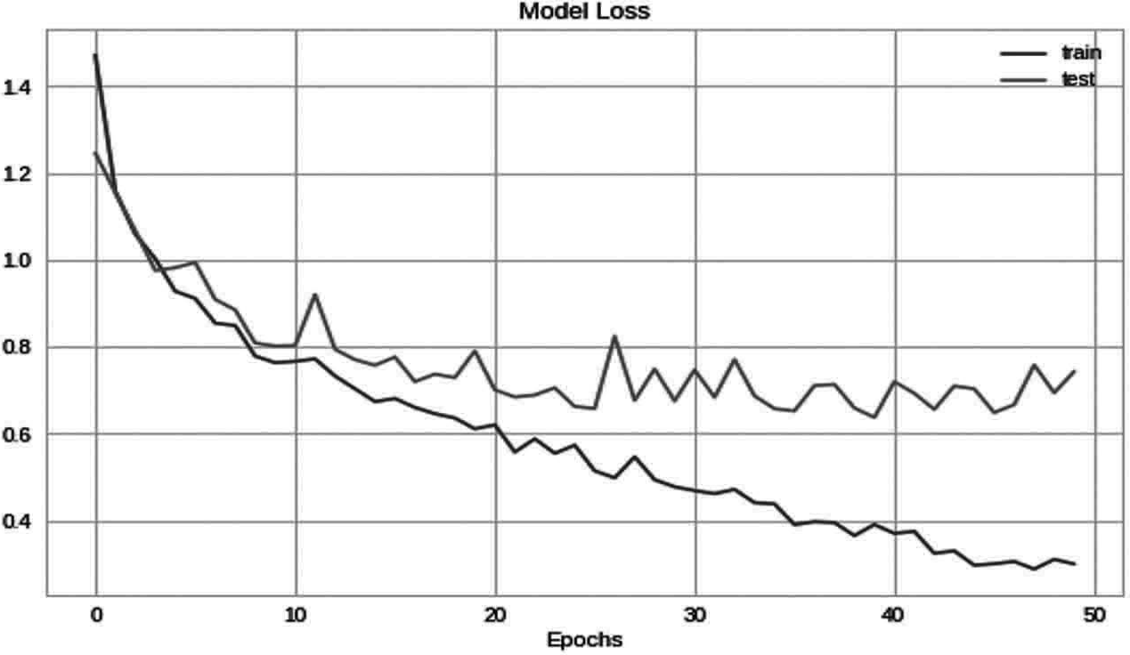
plt.plot (History.history['acc']) plt.plot (History.history['val _ acc']) plt.title ('Model Accuracy') plt.ylabel ('Accuracy')
plt.xlabel ('Epochs') plt.legend (['train', 'test']) plt.show ()
Fig. 11.2 Loss Representation of Model

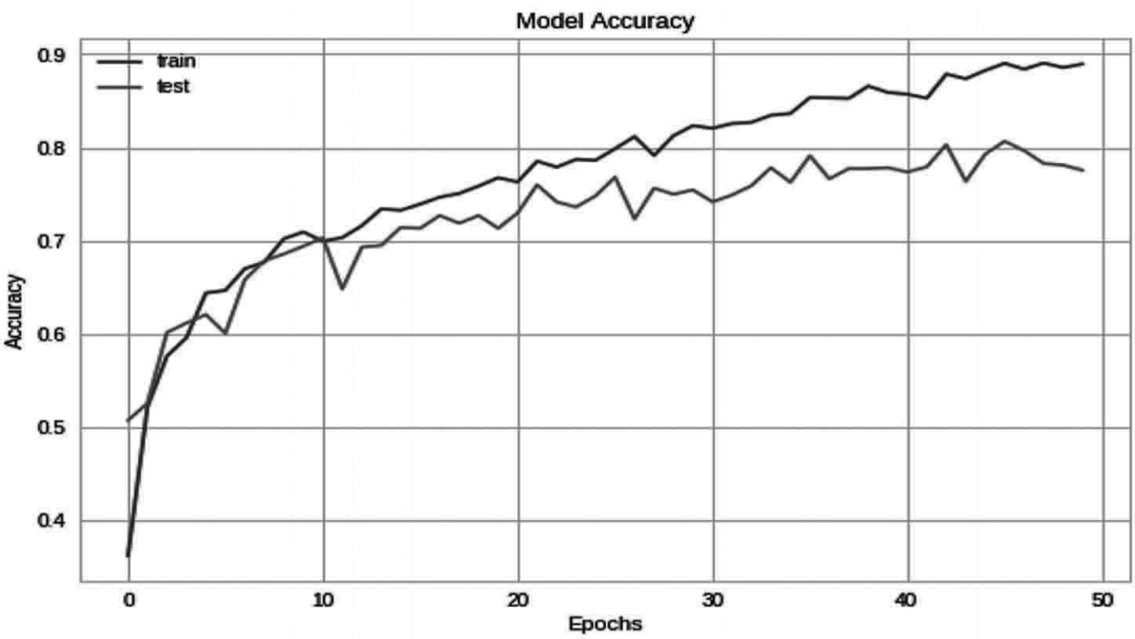
Output: as in Fig. 11.3

Fig. 11.3 Accuracy Representation of Model

Step 9: Prediction on validation data
Here we will get our trained model to predict the images with the validation data which we have separated while labelling and splitting our data.
# getting predictions on val set. pred=model.predict (x _ test)
pred _ digits=np.argmax (pred,axis=1)
# now storing some properly as well as misclassified indexes. i=0
prop _ class=[] mis _ class=[]
Here we are importing images from the validation data to test the model for its prediction.
for i in range (len (y _ test)):
if (np.argmax (y _ test[i])==pred _ digits[i]): prop _ class.append (i)
if (len (prop _ class)==8): break

i=0
for i in range (len (y _ test)):
if (not np.argmax (y _ test[i])==pred _ digits[i]): mis _ class.append (i)
if (len (mis _ class)==8): break

warnings.filterwarnings ('always') warnings.filterwarnings ('ignore') count=0
fig,ax=plt.subplots (4,2) fig.set _ size _ inches (15,15) for i in range (3):
for j in range (2):

ax[i,j].imshow (x _ test[prop _ class[count]])
ax[i,j].set _ title ("Predicted Flower : "+str (le.inverse _ transform ([pred _ digits[prop _ class[count]]]))+"\n"+"Actual Flower : "+str (le.inverse _ transform (np.argmax ([y _ test[prop _ class[count]]]))))
plt.tight _ layout () count+=1
Output: as in Fig. 11.4
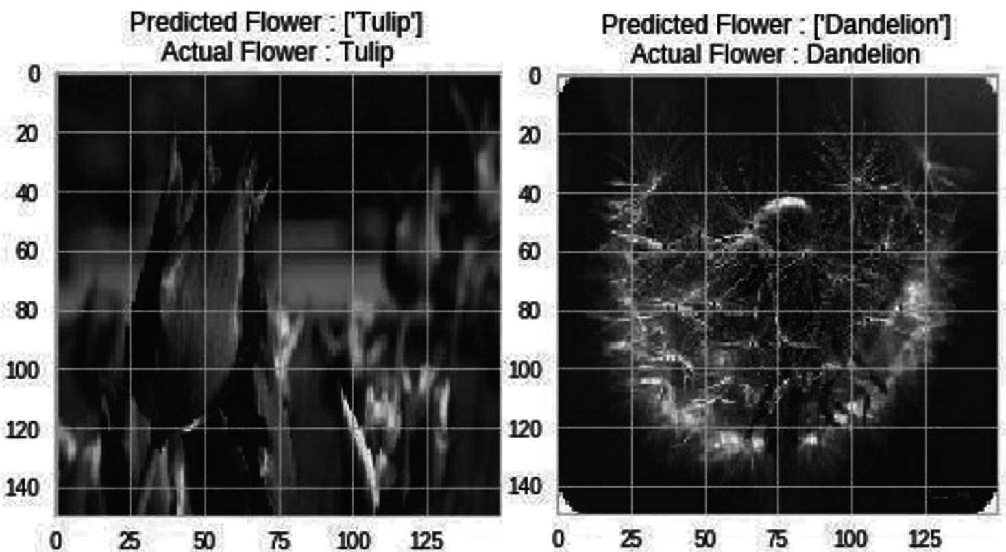
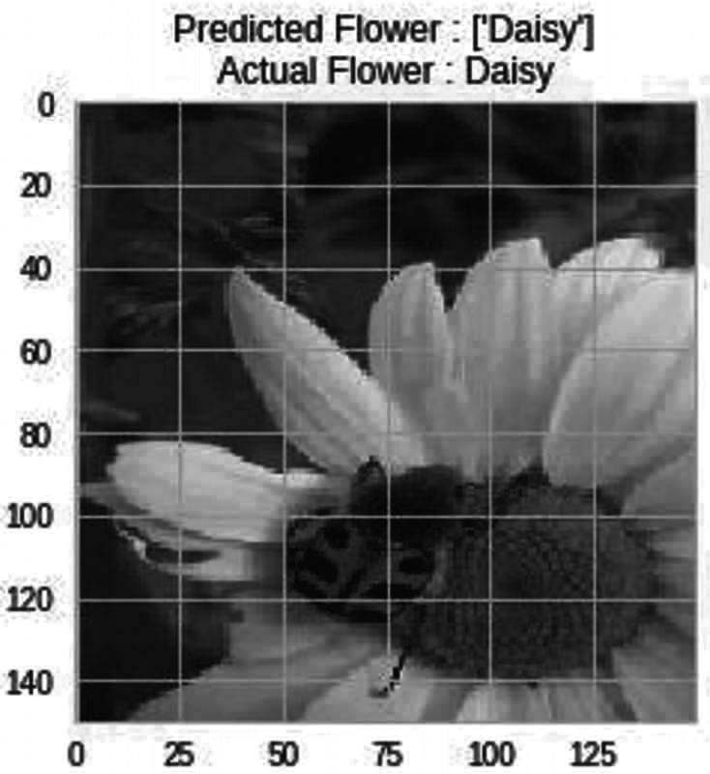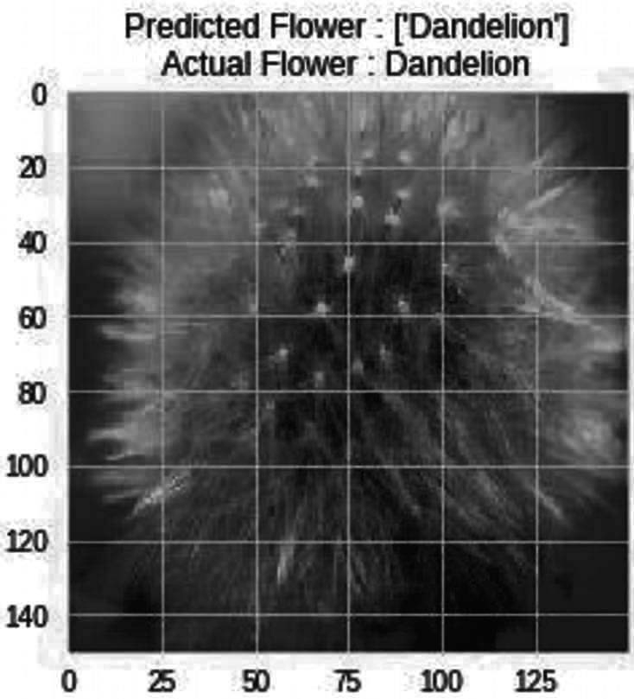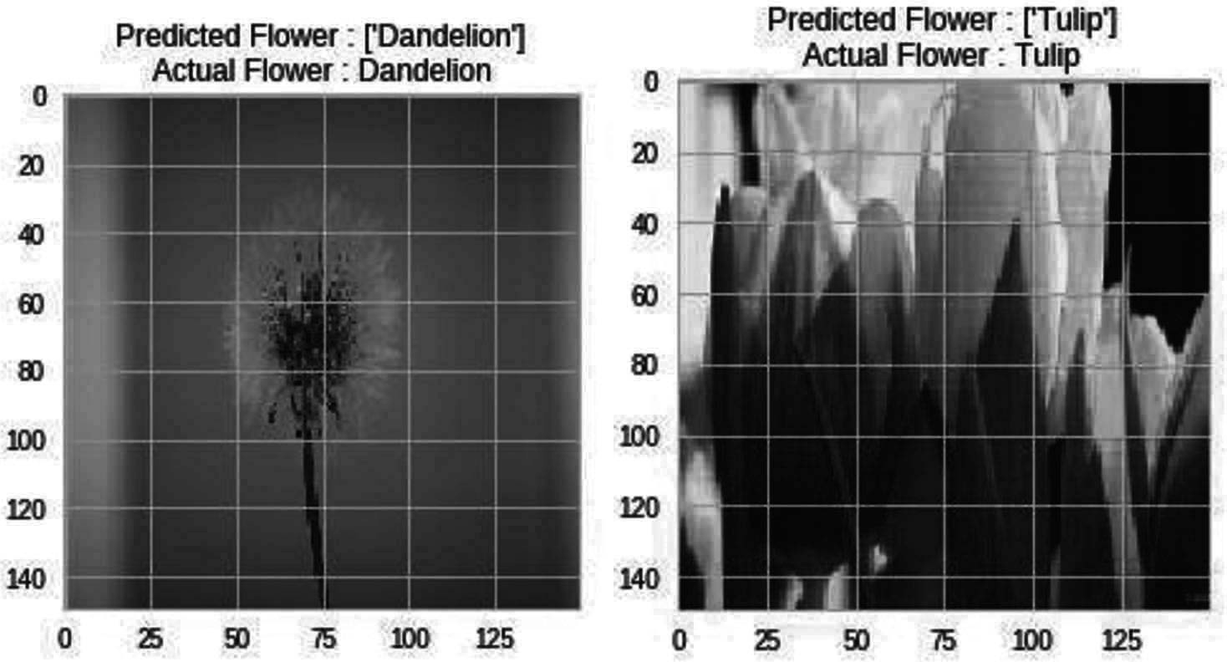

Fig. 11.4 Prediction of flowers
Step 10: Saving the model
This is the way to save a model which we have trained
model _ json = model.to _ json ()
with open ("model.json", "w") as json _ file:
json _ file.write (model _ json) # serialize weights to HDF5 model.save _ weights ("model.h5") print ("Model Saved")
After saving this model we can predict the values under these categories just by using the images of those species.

Summary
Species Recognition also plays an important role in the field of agriculture which can help a lot of people to identify the plant species digitally and it will last long with a guarantee that our system is correct to identify a species of plant. In this chapter we have worked on one more project which is related to species recognition and we can totally understand how to use the dataset with machine learning, deep learning and computer vision for better understand and real time use of artificial Intelligence. In the Species recognition we have used flower dataset to train our model for classification and identification of flowers in Realtime. This project can be used in Realtime to identify the species of flowers digitally by just from images of flowers

Bibliography
Rajesh Singh, Anita Gehlot, Sushabhan Choudhury, Bhupendra Singh, “Embedded System based on ATmega Microcontroller-Simulation, Interfacing and Projects”, Narosa Publishing House, 2017, ISBN: 978-81-8487-5720.
Rajesh Singh, Anita Gehlot, Bhupendra Singh, Sushabhan Choudhury, “Arduino-Based Embedded Systems: Interfacing, Simulation, and LabVIEW GUI”- CRC Press (Taylor & Francis), 2017, ISBN 9781138060784.
Anita Gehlot, Rajesh Singh, Devender Kumar Saini, Monika Yadav, Bhupendra Singh, “IoT Enabled Smart Microgrid…..Rapid Prototyping”, GBS Publication, 2018, ISBN: 978-93- 87374-41-6.
Anita Gehlot, Rajesh Singh, Mamta Mittal, Bhupendra Singh, Ravindra Sharma, Vikas Garg, “Hands on approach on Applications of Internet of Things in various Domain of Engineering”, International Research Publication House, 2018, ISBN: 978-93-87385-25-3.
Rajesh Singh, Anita Gehlot, Bhupendra Singh, Sushabhan Choudhury, “Internet of Things Enabled Automation in Agriculture”, New India Publishing Agency, 2018, ISBN: 9789387973053.
Rajesh Singh, Anita Gehlot, Bhupendra Singh, Bikarama Prasad Yadav, “IoT Enabled Fire Safety and Security Devices for Building”, Pen2Print, EduPedia Publications, 2018, ISBN:9789386647979.

Rajesh Singh, Anita Gehlot, Bhupendra Singh, Piyush Kuchhal, “Wireless Methods and Devices for Home Automation” International Research Publication House, 2018, ISBN: 978-93- 87388-27-7.
Rajesh Singh, Anita Gehlot, Raghuveer Chimata, Bhupendra Singh, P.S.Ranjith, “Internet of Things in Automotive Industries and Road Safety” River Publishers, 2018, ISBN:9788770220101&e-ISBN:9788770220095
Rajesh Singh, Anita Gehlot, Bhupendra Singh, Sushabhan Choudhury, “Arduino meets MATLAB…. Interfacing, Programs and Simulink”, Bentham Science, 2018, ISBN: 978-1- 68108-728-3 & e-ISBN: 978-1-68108-727-6
Rajesh Singh, Anita Gehlot, Lovi Raj Gupta, Bhunpendra Singh, and Priyanka Tyagi, “Getting Started for Internet of Things with Launch Pad and ESP8266”, River Publishers, 2019, ISBN: 9788770220682, e-ISBN: 9788770220675
Rajesh Singh, Anita Gehlot, Bhunpendra Singh, “Arduino and Scilab based Projects”, Bentham Science, 2019, ISBN: 9789811410918 & e-ISBN: 9789811410925
Anita Gehlot, Rajesh Singh, Lovi Raj Gupta, Bhupendra Singh, “Cook Book for Mobile Robotic Platform Control with Internet of Things and Ti Launch Pad”, BPB Publisher, 2019, ISBN: 978-93-8851-167-4
Rajesh Singh, Anita Gehlot, Lovi Raj Gupta, Bhupendra Singh, Mahindra Swain, “Internet of Things with Raspberry Pi and Arduino”, CRC press/Taylor & Francis, 2019, ISBN: 9780367248215
Anita Gehlot, Rajesh Singh, Gaurav Sethi, Bhupendra Singh, “The Robotic Platform Control with Atmega328 and NuttyFi Based on the Internet of Things”, Nova Science Publisher, 2020, ISBN:9781536174724
Rajesh Singh, Anita Gehlot, Lovi Raj Gupta, Navjot Rathour, Mahendra Swain, Bhupendra Singh, “IoT based projects”, BPB publication, 2020, ISBN: 9789389328523

